# PRACTICAL – 7

**Aim:** **Process control system calls:**

**A**: **The demonstration of fork()**

**PROGRAM:**

#include <stdio.h>

#include <sys/types.h>

#include <unistd.h>

int main()

{

fork();

printf("Hello world!\n");

return 0;

}

**OUTPUT:**

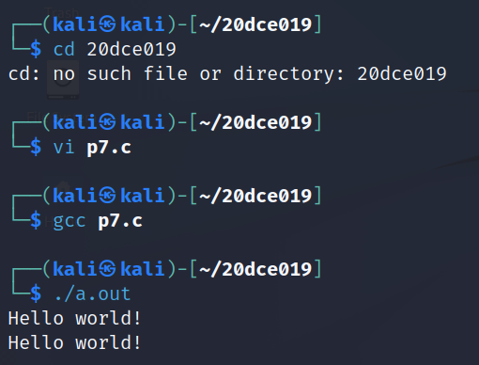

**B**: **execve() and wait() system calls along with zombie and orphan states.**

**PROGRAM:**

**OUTPUT:**